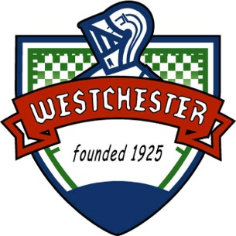

**Board of**

**Fire and Police Commissioners**

**Commission Chair**

Ruth Gudino

**Commissioner**

Brian Kuratko

**Commissioner**

Thomas B. McCarthy III

**Village of Westchester**

**10300 Roosevelt Road, Westchester, IL 60154**

**(708)345-0020 FAX (708)345-2873  
www.westchester-il.org**

**MEETING MINUTES**

**FIRE AND POLICE COMMISSION MEETING**

**January 5, 2015**

**CALL TO ORDER:**

The meeting was called to order at 6:30pm and followed by the Pledge of Allegiance. Responding present to roll call were Commission Chairperson Ruth I. Gudino, Commissioner Brian Kuratko and Commissioner Thomas McCarthy III. Also present were Fire Chief Jim Adams, Legal Counsel Mike Jurusik and Management Assistant Mary Detente.

**APPROVAL OF MINUTES:**

Commissioner Gudino-Negrete entertained a motion to approve meeting minutes for the December 1, 2014 meeting. A motion was made by Commissioner McCarthy and seconded by Commissioner Kuratko to approve the December 2014 meeting minutes. The motion passed unanimously. Commissioner Gudino entertained a motion to table the meeting minutes approval for the November 3, 2014 meeting. Motion by Commissioner Kuratko and seconded by Commissioner McCarthy. Motion passed unanimously.

**NEW BUSINESS:**

Commissioner Gudino reported that she would have the 2014 Annual Report for the Board of Fire and Police Commission ready for review at the February meeting.

Commissioner Kuratko reported that he has submitted a budget worksheet to Maureen Potempa for the Board of Fire and Police Commission for the Fiscal Year 2016.

**OLD BUSINESS:**

Attorney Mike Jurusik updated the Board Members on some changes that were made to the Rules and Regulations as it related to recent state statute changes in regards to the mean vs. median scoring system. These changes were as a result of a Department of Justice case review.

There was a brief discussion on the status of the Entry Level Police Officer Testing and eligibility list. Motion by Commissioner Gudino to table and seconded by Kuratko. Motion passed unanimously.

**INFORMATION ONLY:**

Next Meeting will be held on February 2, 2014 at 6:30pm.

**PUBLIC PARTICIPATION:**

There was no public participation or comments.

**EXECUTIVE SESSION: None**

**ADJOURNMENT:**

With no further business to discuss, Commissioner McCarthy made a motion, seconded by Commissioner Kuratko to adjourn the meeting. Meeting adjourned at 7:05pm.